Determinants of Income Inequality in Latin America

Joshua Winter

05/01/2018

Statistical Computing 689

**Part I: Introduction to Income Distributions and Inequality Metrics**

Over the past three decades, the topic of how income is distributed throughout the population has become ever more important for both the United States and the world as a whole. Oftentimes, the level of wealth dispersion (income) is the first thing that comes to mind when someone hears the words “equality” or “inequality.” Aside from income, social equality issues such as the rights of men and women, people of different ethnic backgrounds, and sexual orientation tend to be the primary topics of public discourse. The reality is that statisticians, policy makers, and economists have found methods for quantifying nearly all of them. However, for our purposes, the primary focus will be on metrics to quantify income distributions and income inequality.

When it comes to measuring income inequality, the following are the most commonly utilized metrics (in alphabetical order): 20:20 Index, Atkinson Index, Gini Coefficient, Coefficient of Variation, Generalized Entropy Index, Hoover Index, Mean Log Deviation (MLD), Palma Ratio, Theil Index, and Wage Share. In the most general terms, each of the metrics accomplishing a roughly similar measurement and will give you a similar result. None are perfect, however, and each may have a different scale or means of calculation. The Hoover Index is by far the simplest; it calculates the proportion of all income that would have to be redistributed in order to achieve perfect equality. Of the ten listed here, the most commonly used are the Atkinson Index, the Theil Index, and the Gini Coefficient. These methods are therefore the focus of the research to follow.

**Part 1 Section A: Sample Data Generation**

Prior to examining the data and metrics themselves, it is important to generate some sample data in R such that we can illustrate the way the calculations work. Although the names of actual countries are used, none are intended to be an accurate representation and are purely used for convenience. To keep things simple, each country has ten sample incomes associated. An alternative method would be to generate several random sets of data using one of R’s pseudo-random number generators; however, this method would make it difficult to determine the accuracy of our results.

Sample Data:

US<-c(50000, 50000, 50000, 50000, 50000, 45000, 45000, 40000, 55000, 55000)

UK<-c(70000, 80000, 75000, 20000, 20000, 20000, 80000, 15000, 15000, 15000)

SK<-c(20000, 20000, 25000, 20000, 25000, 30000, 30000, 30000, 27500, 22500)

NK<-c(1000000, 100000, 1000, 1000, 250000, 5000, 5000, 2000, 2000, 2000)

SA<-c(6000,5000,5000,5000,4750,4500,4500,5500,5250,5000)

CA<-c(1,10,30,2500,50000,4500,100000,15000,500,65000)

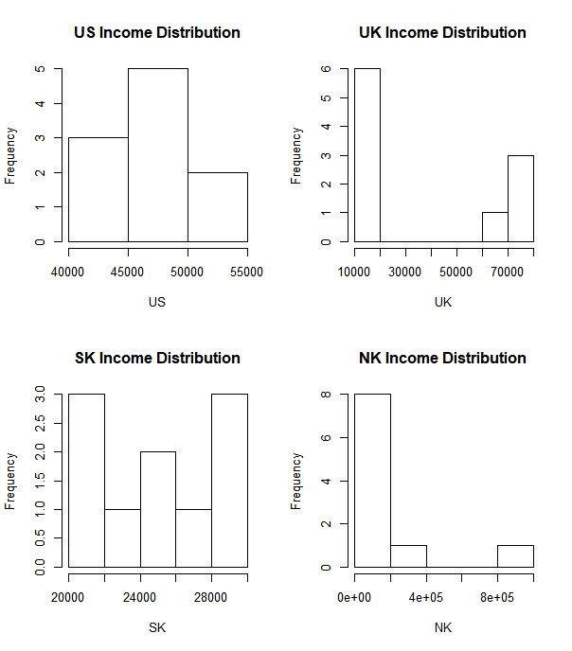

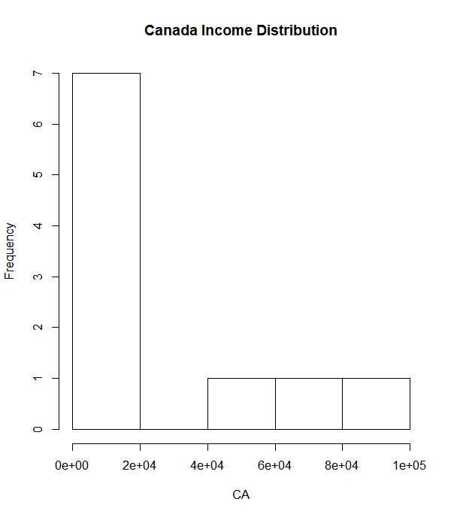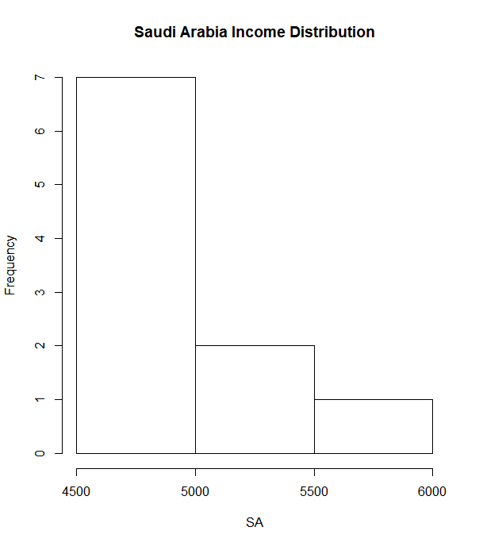

**Part I Section B: The Atkinson Index**

The Atkinson Index was developed by British economist Anthony Aktinson. Most commonly, it is used to identify which end of the income distribution contributed most to the observed inequality; in essence, it assigns a weight to varying income levels. Intuitively, Atkinson values can be used to calculate the proportion of income that would be required to be given up in order to achieve an equal level of social welfare as if incomes were evenly distributed across society. For example, an Atkinson index value of 0.4 suggests that we could achieve the same level of social welfare with only 1–0.40 = 60% of income. The range for the Atkinson Index is from 0 to 1, with 0 being perfectly distributed. Compared to many other income distribution metrics, the Index is relatively easy to implement in most statistical software languages or programs such as R, Stata, SAS, and Python. The code below is an example of what it would look like written in R, where x is a vector of incomes and the parameter is a measure of inequality aversion that is typically set to .5 (50%).

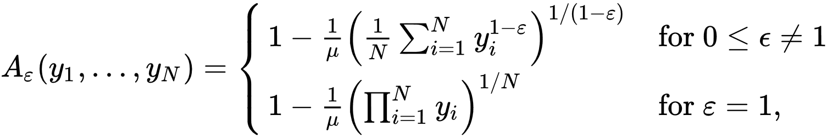

Atkinson<-function (x, parameter = 0.5, na.rm = TRUE)

{

if (!na.rm && any(is.na(x)))

return(NA_real_)

x <- as.numeric(na.omit(x))

if (is.null(parameter))

parameter <- 0.5

if (parameter == 1)

A <- 1 - (exp(mean(log(x)))/mean(x))

else {

x <- (x/mean(x))^(1 - parameter)

A <- 1 - mean(x)^(1/(1 - parameter))

}

A

}

While obtaining data for the incomes of individuals is very difficult, we can use the sample data from earlier for a few examples (US, UK, and NK) of what the results might look like if one were to use the function in real life.

Atkinson(US,parameter = .5, na.rm = TRUE)

[1] 0.002036128

> Atkinson(UK,parameter = .5, na.rm = TRUE)

[1] 0.1233919

> Atkinson(NK,parameter = .5, na.rm = TRUE)

[1] 0.660506

Per the above index calculations, the United States is the most equal of the three countries, with less than 1% of income needing to be given up in order to achieve social welfare equality (1 – Atkinson Index). North Korea is the most unequal; they would need to give up 35% of their current income.

**Part I Section C: The Theil Index**

The Theil Index, a special case of the Generalized Entropy Index, is often used as a measure of redundancy, lack of diversity, isolation, segregation, inequality, non-randomness, and compressibility. Henri Theil, creator of the Theil Index, once stated the Index can be described “as the expected information content of the indirect message which transforms the population shares as prior probabilities into the income shares as posterior probabilities.” In simpler terms, it can be understood as the summation of the weighted difference of the logarithms of the shares. When there is perfect equality, the sum will be zero.

Similar to the Atkinson Index, the Theil is relatively easy to implement in R.

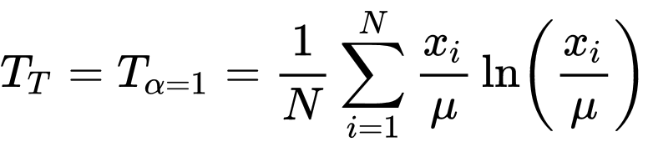

Theil<-function (x, parameter = 0, na.rm = TRUE)

{

if (!na.rm && any(is.na(x)))

return(NA_real_)

x <- as.numeric(na.omit(x))

if (is.null(parameter))

parameter <- 0

if (parameter == 0) {

x <- x[!(x == 0)]

Th <- x/mean(x)

Th <- sum(x * log(Th))

Th <- Th/sum(x)

}

else {

Th <- exp(mean(log(x)))/mean(x)

Th <- -log(Th)

}

Th

}

From the sample that we generated earlier, we can compute the Theil for the US, UK, NK, SK,CA, and SA. Note that the results are somewhat similar, as expected.

Theil(US)

[1] 0.004031139

Theil(UK)

[1] 0.2472492

Theil(SK)

0.01308298

Theil(NK)

[1] 1.491488

Theil(SA)

[1] 0.003562459

Theil(CA)

[1] 0.9436548

**Part 1 Section D: The Gini Coefficient and Lorenz Curve**

Of all the measures of inequality, the Gini Coefficient is the most well-known and widely used. It is characterized as a measure of statistical dispersion which represents the wealth distribution of a nations’ residents in terms of frequency.

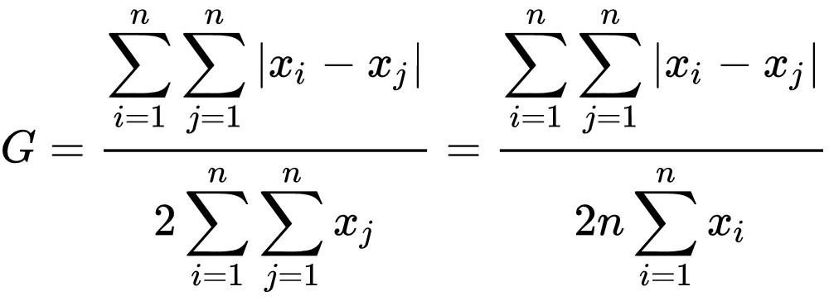

Values for the Gini Coefficient range from 0 to 1, with 0 representing perfect equality and 1 indicating a state of complete inequality. The coefficient itself is usually defined mathematically based on the Lorenz Curve, which plots cumulative share of income earned on the y-axis and cumulative share of people from lowest to highest incomes on the x-axis.



Therefore, the Gini is intuitively thought of as the ratio of the area that lies between the line of equality and the Lorenz curve over the total area under the line of equality.

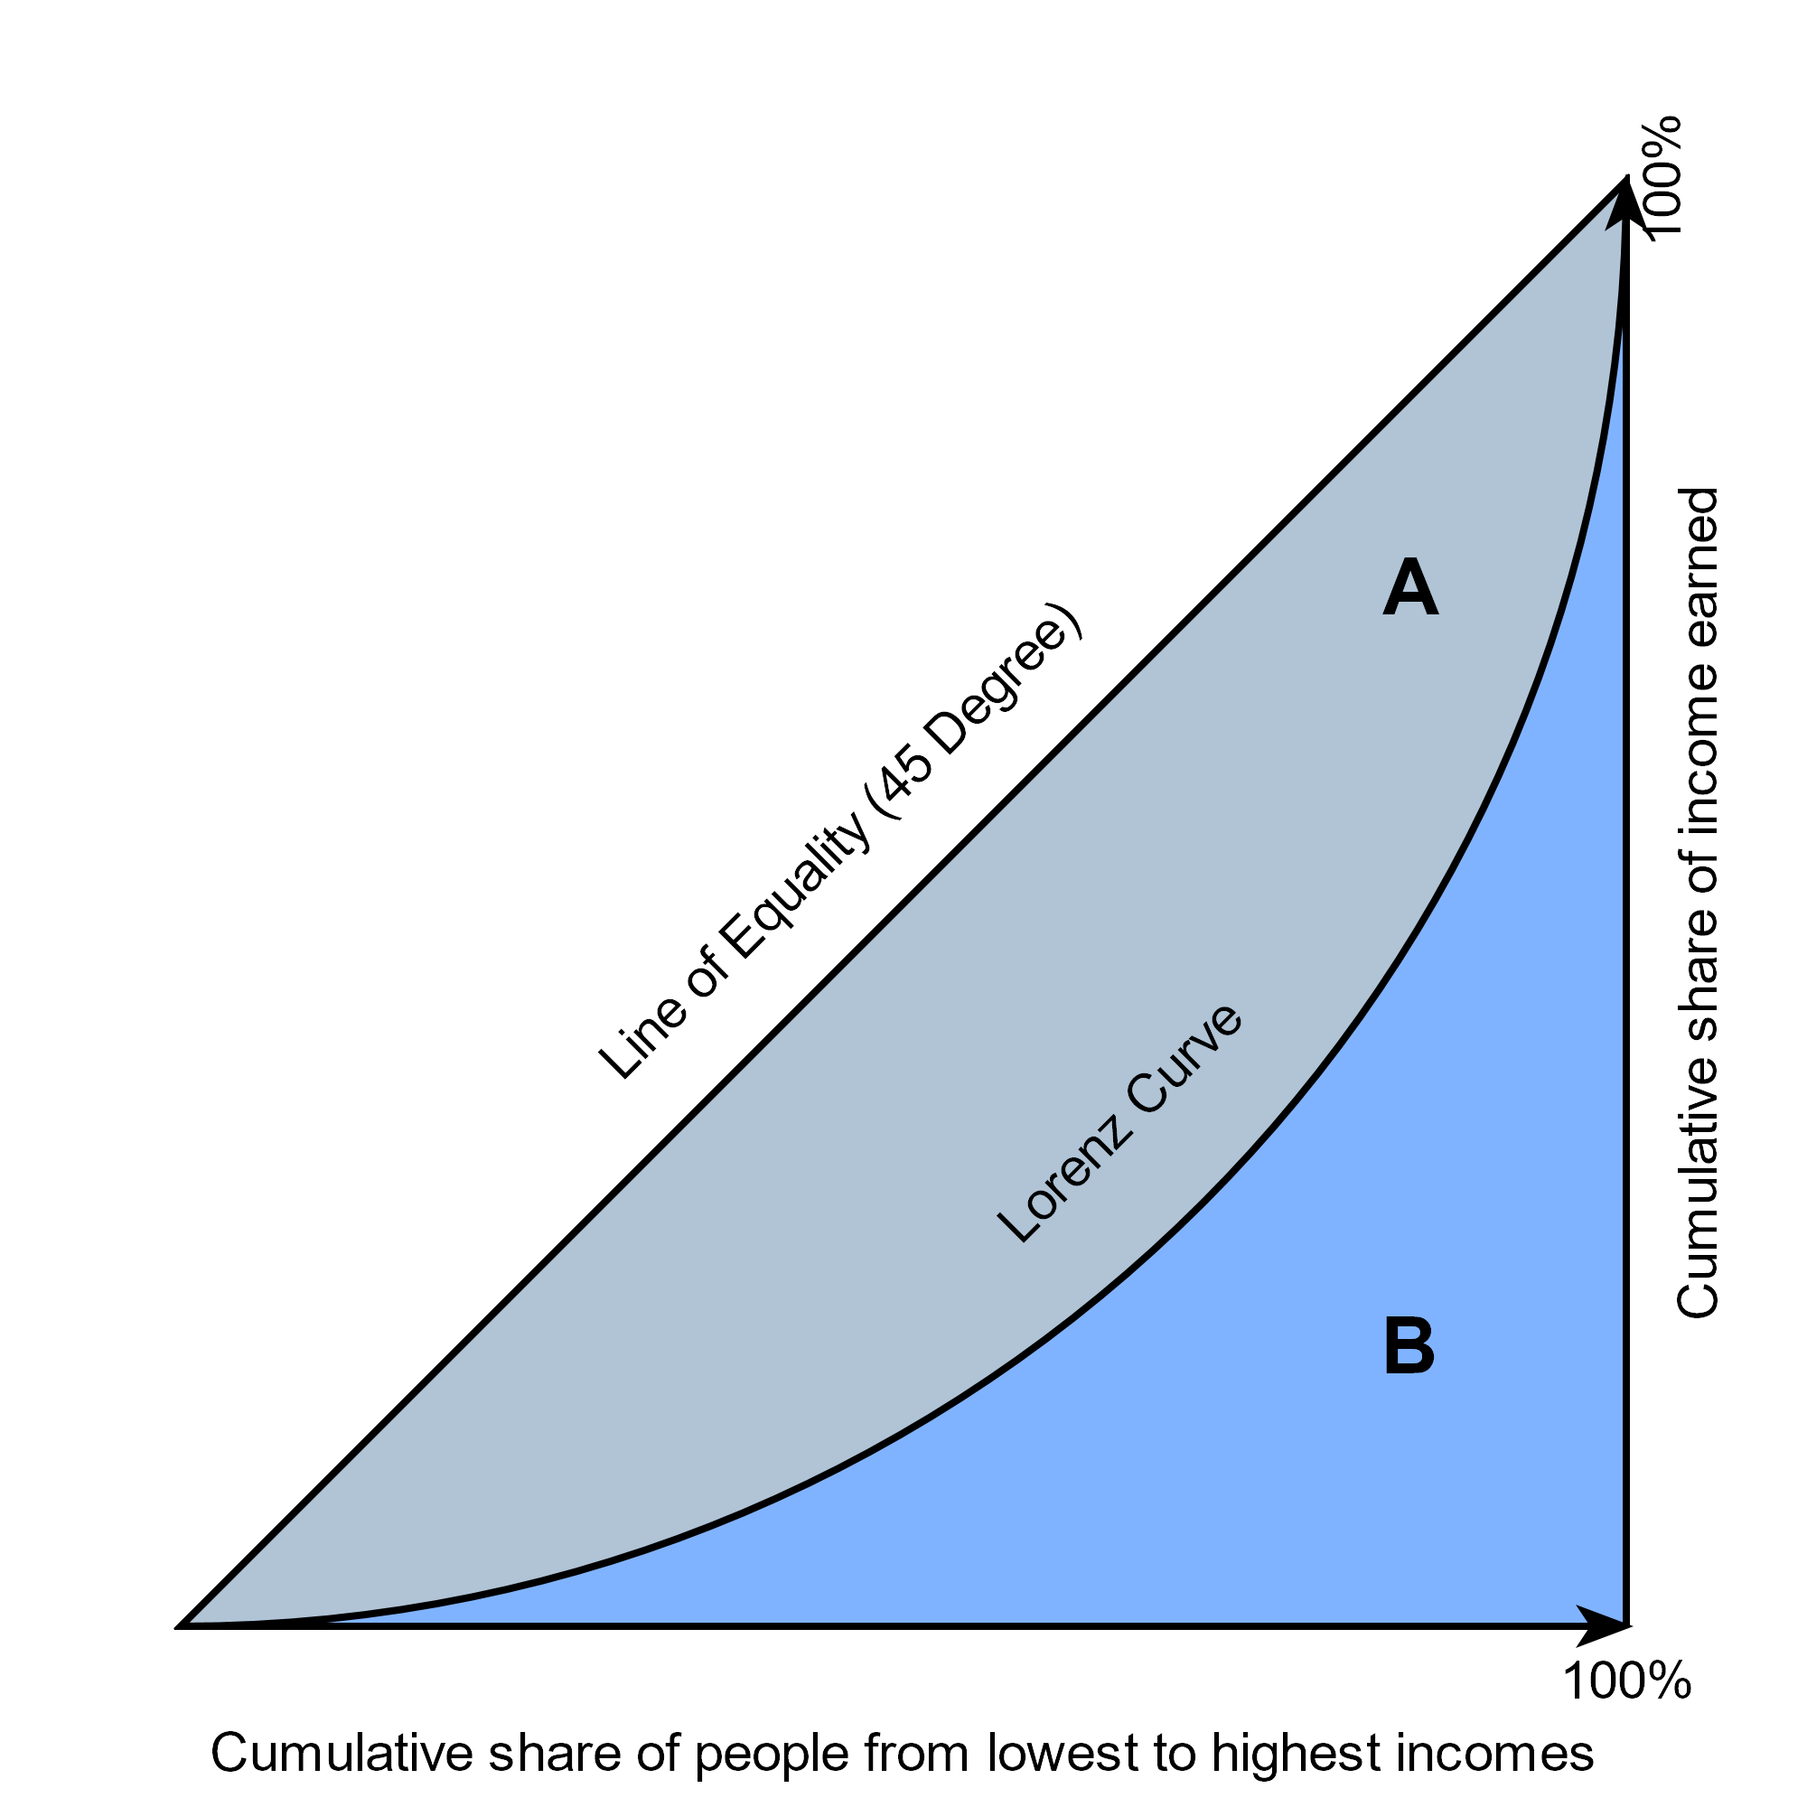

Like the Atkinson and the Theil Index, the Gini Coefficient and Lorenz Curve can be written in R. Code for the Gini Coefficient is below.

Gini<-function (x, n = rep(1, length(x)), unbiased = TRUE, conf.level = NA,

R = 1000, type = "bca", na.rm = FALSE)

{

x <- rep(x, n)

if (na.rm)

x <- na.omit(x)

if (any(is.na(x)) || any(x < 0))

return(NA_real_)

i.gini <- function(x, unbiased = TRUE) {

n <- length(x)

x <- sort(x)

res <- 2 * sum(x * 1:n)/(n * sum(x)) - 1 - (1/n)

if (unbiased)

res <- n/(n - 1) * res

return(pmax(0, res))

}

if (is.na(conf.level)) {

res <- i.gini(x, unbiased = unbiased)

}

else {

boot.gini <- boot(x, function(x, d) i.gini(x[d], unbiased = unbiased), R = R)

ci <- boot.ci(boot.gini, conf = conf.level, type = type)

res <- c(gini = boot.gini$t0, lwr.ci = ci[[4]][4], upr.ci = ci[[4]][5])

}

return(res)

}

When calculating the Gini Coefficient for each of the countries previously focused on with the Theil and Atkinson Indexes, similar results are again generated which indicate that Canada and North Korea are the most unequal.

Gini(US,n=rep(1,length(US)),unbiased=TRUE,conf.level = NA,R=1000,type = "bca",na.rm = FALSE)

[1] 0.0521542

Gini(UK,n=rep(1,length(UK)),unbiased=TRUE,conf.level = NA,R=1000,type = "bca",na.rm = FALSE)

[1] 0.403794

Gini(SK,n=rep(1,length(SK)),unbiased=TRUE,conf.level = NA,R=1000,type = "bca",na.rm = FALSE)

[1] 0.1

Gini(NK,n=rep(1,length(NK)),unbiased=TRUE,conf.level = NA,R=1000,type = "bca",na.rm = FALSE)

[1] 0.9126056

Gini(SA,n=rep(1,length(SA)),unbiased=TRUE,conf.level = NA,R=1000,type = "bca",na.rm = FALSE)

[1] 0.05060506

Gini(CA,n=rep(1,length(CA)),unbiased=TRUE,conf.level = NA,R=1000,type = "bca",na.rm = FALSE)

[1] 0.7719233

The Lorenz Curve can then be written in R as follows.

Lc<-function (x, n = rep(1, length(x)), plot = FALSE)

{

ina <- !is.na(x)

n <- n[ina]

x <- as.numeric(x)[ina]

k <- length(x)

o <- order(x)

x <- x[o]

n <- n[o]

x <- n * x

p <- cumsum(n)/sum(n)

L <- cumsum(x)/sum(x)

p <- c(0, p)

L <- c(0, L)

L2 <- L * mean(x)/mean(n)

Lc <- list(p, L, L2)

names(Lc) <- c("p", "L", "L.general")

class(Lc) <- "Lc"

if (plot)

plot(Lc)

Lc

}

As we have done with all of the other inequality measures to this point, we can calculate the values for the Lorenz Curve. After the values have been calculated they can be stored in a data frame and be plotted so we can see a visual representation of what the curve looks like. On this exercise we will use the same countries as in previous examples however only code and output for the first country will be shown although all graphs will be displayed. The rest of the code will be made available on Github.

Lc(US)

$p

[1] 0.0 0.1 0.2 0.3 0.4 0.5 0.6 0.7 0.8 0.9 1.0

$L

[1] 0.00000000 0.08163265 0.17346939 0.26530612 0.36734694 0.46938776 0.57142857 0.67346939 0.77551020 0.88775510 1.00000000

$L.general

[1] 0 4000 8500 13000 18000 23000 28000 33000 38000 43500 49000

attr(,"class")

[1] "Lc"

US<-Lc(US, n = rep(1,length(US)), plot =F)

plot(US$p,US$L,

col="blue",

type="b",

lty=5,

lwd=2,

main="United States Lorenz Curve")

On the following page, we see the graphs output by these functions.

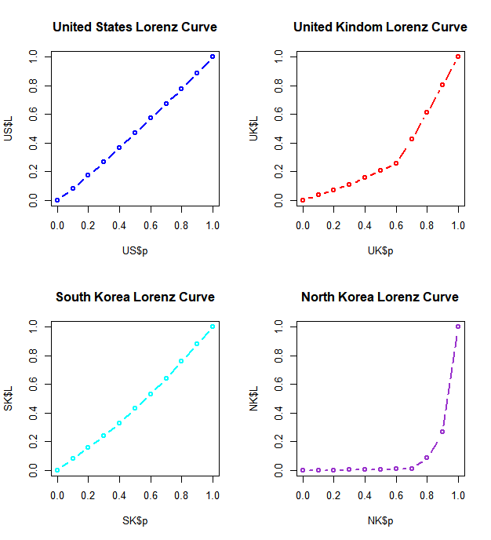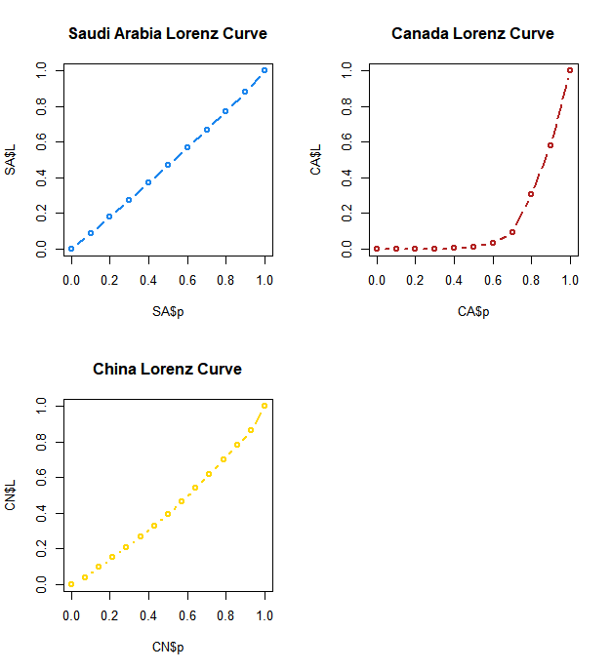

**Part II: Inequality in Latin America**

Home to 23 countries and over 650 million people, Latin America represents approximately 1/11th of the world population and 1/12th of the its total GDP (under Purchasing Power Parity). The region is also responsible for producing 16% of the world’s agricultural products and a substantial amount of its natural resources. Since the 1950’s, Latin America has become one of the most unequal regions in the world from an income distribution standpoint, peaking in terms of inequality in the late 1990’s and declining thereafter. See the chart below for a graphical representation of this (recreated from Nora Lustig’s data).

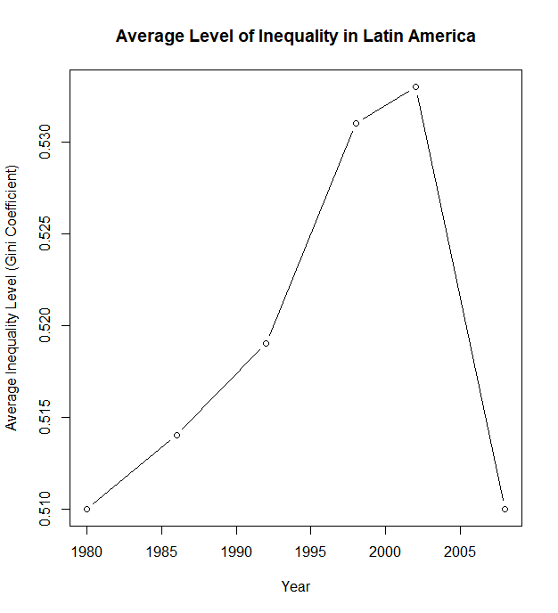

Numerous economists and policymakers have offered explanations for why the decline has occurred, the majority of which are back up by scientific and statistical research; a few are listed below.

1. Lower inflation rates (Perry, Lopez).
2. Strong GDP growth, higher tax revenues, and increased FDI (Tsounta, Osueke).
3. Decline in the informal sector workforce (Acemoglu).
4. Use of income redistribution programs and industrial privatization (Cornia, Mortorano).
5. More stable monetary and fiscal policy collectively as a region (Perry, Lopez).
6. Higher participation rate of the poor in the workforce and a decline in the wage premium for education (Addison).
7. Signing of NAFTA and increased trade (Robertson).

**Part II Section A: Introduction to Nora Lustig’s Work**

Having dedicated much of her career to the topic of inequality, Nora Lustig is one of today’s preeminent and most well-respected scholars on the subject. Currently, she is a professor of Latin American Economics at Tulane University. From 2010 to 2013 she wrote several articles on the topic; however, our focus will be “The decline in inequality in Latin America”, “The rise and fall of income inequality in Latin America”, and “Deconstructing the decline of inequality in Latin America”. In these three articles, she discusses the fact that the Gini Coefficient decreased in 13/16 (the largest countries in Latin America) of the countries she looked at from 2000-2010, contemporaneously the percent of people in poverty in the region declined substantially. A list of countries is below.

|  |  |  |
| --- | --- | --- |
| 1. Argentina 2. Bolivia 3. Brazil 4. Chile 5. Costa Rica 6. Dominican Republic | 1. Ecuador 2. El Salvador 3. Guatemala 4. Mexico 5. Nicaragua 6. Panama | 1. Paraguay 2. Peru 3. Uruguay 4. Venezuela |

In her research, Lustig defined and quantified poverty in two ways: the percent of people living on $2.5 per day or less and the percent living on $4 per day or less; since 1992 both have fallen off substantially.

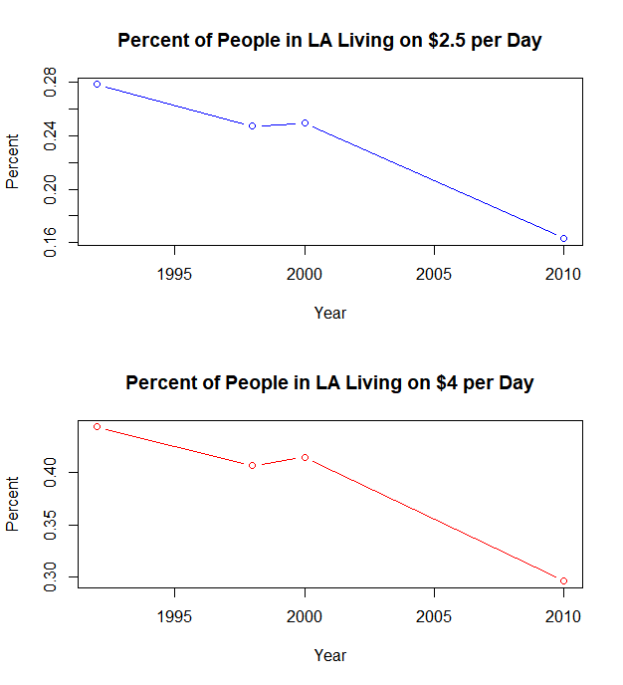

While Lustig offered many explanations in each article for the decline, the following will be the focus of debate and discussion here:

1. Declines in terms of returns to education at the primary, secondary, and tertiary levels.

2. Decline in the wage premium for skilled workers

3. Changes in supply and demand for unskilled workers.

It is important to note that Lustig’s research was originally conducted using STATA and Excel while all of the analysis for this paper was done using R. The majority of the data was compiled in the same manner and from the same sources that Lustig originally used. Interestingly enough, some of the conclusions that will be drawn differ from Lustig’s and could be indicative of a lack of reproducibility of her work. Due to the way some of the data was laid out, the decline in wage premiums of skilled labor and changes in supply and demand for unskilled workers will be discussed contemporaneously.

**Part II Section B: Returns on Education**

According to Lustig, one of the primary reasons inequality has decreased in recent years is due to a decline in returns on education, meaning that there is a smaller gap between the incomes of those who are high school educated vs college educated. By examining frequency distributions for the average annual percent change in returns for the 16 countries mentioned earlier, we can see that from 2000-2010 there is some degree of correlation between the decline in inequality and the returns on education. For this study, primary, secondary, and tertiary education have been examined in addition to average change across all education tiers (coded as P, S, T, and x in R) for change in returns on education. Histograms for all four are below. The Gini and plots for each average annual percent change in returns to education for each tier vs the average annual percent change in the Gini may be found on the following page.

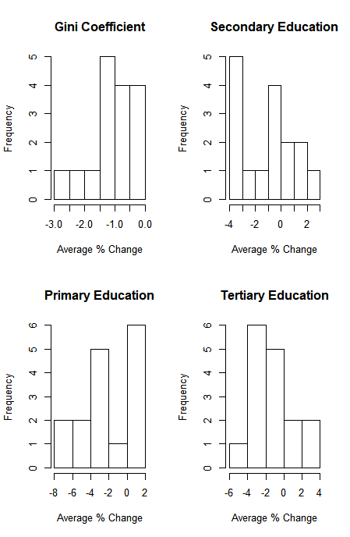

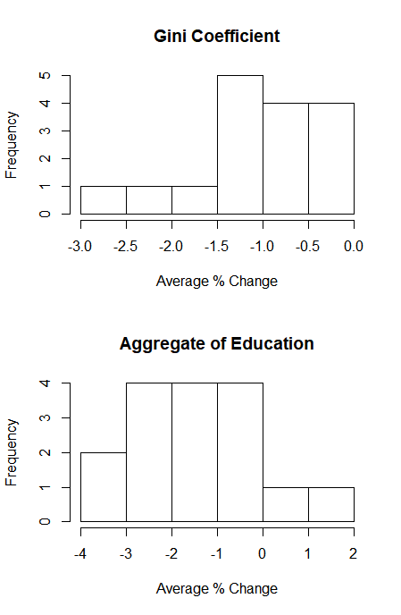

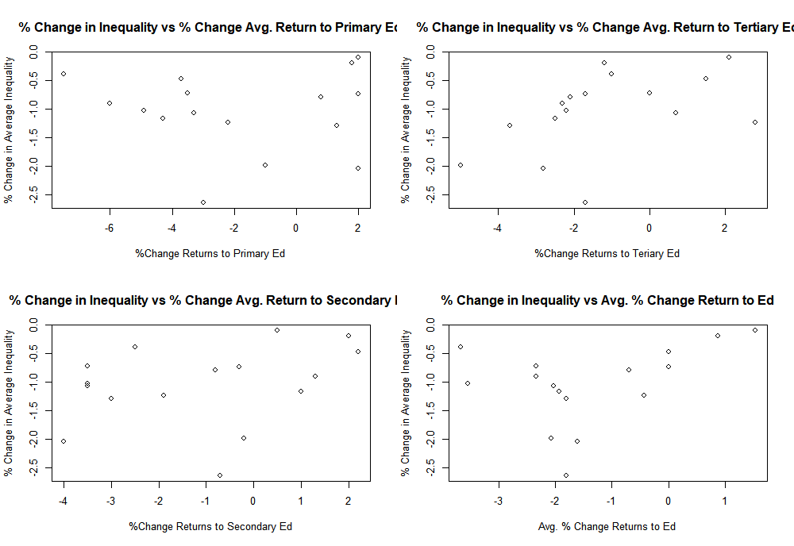

In order to better test Lustig’s analysis and her conclusion that inequality was impacted by education, four linear regressions against the Gini Coefficient were ran in R: one for each education tier and one for the aggregate. Output for the aggregate is below, and output for the other three can be found using the code posted on GitHub.

> summary(lm(formula = y ~ x))

Call:

lm(formula = y ~ x)

Residuals:

Min 1Q Median 3Q Max

-1.5128 -0.2179 0.1208 0.4117 1.0657

Coefficients:

Estimate Std. Error t value Pr(>|t|)

(Intercept) -0.8111 0.2317 -3.501 0.00353 **

x 0.1756 0.1179 1.490 0.15853

---

Signif. codes: 0 ‘***’ 0.001 ‘**’ 0.01 ‘*’ 0.05 ‘.’ 0.1 ‘ ’ 1

Residual standard error: 0.667 on 14 degrees of freedom

Multiple R-squared: 0.1368, Adjusted R-squared: 0.07514

F-statistic: 2.219 on 1 and 14 DF, p-value: 0.1585

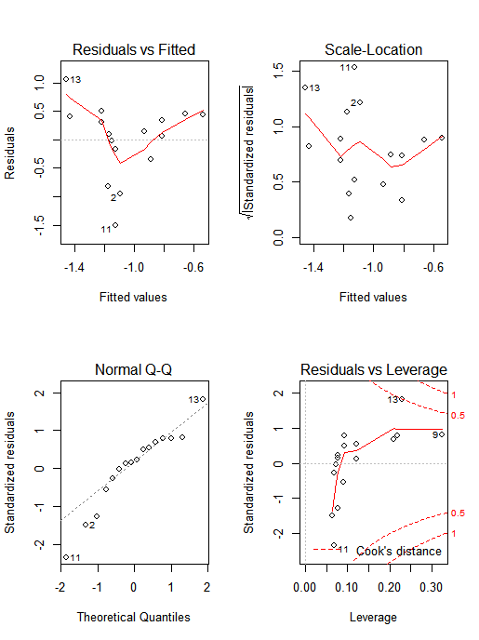

The only regression with significant results is the one in which annual average percent change in the Gini is regressed on annual average percent change in tertiary education. This is a fairly decent contrast to what Lustig originally found, in that she believed there was a causal relationship between all three tiers and the decline of inequality. By itself, this is indicative that some of her research may not be reproducible, or at least not easily.

**Part II Section C: Supply and Demand for Unskilled Workers and Wage Premiums**

Nora Lustig also concluded that the average annual percent change in supply and demand of unskilled workers as well as the wage premium for skilled workers (this could be education, knowledge of a trade, or human capital in general) contributed to the decline of inequality. Once again, this analysis was done using the 16 countries listed previously from 2000-2010. Histograms of each are below as well as plots vs the average annual change in the Gini Coefficient.

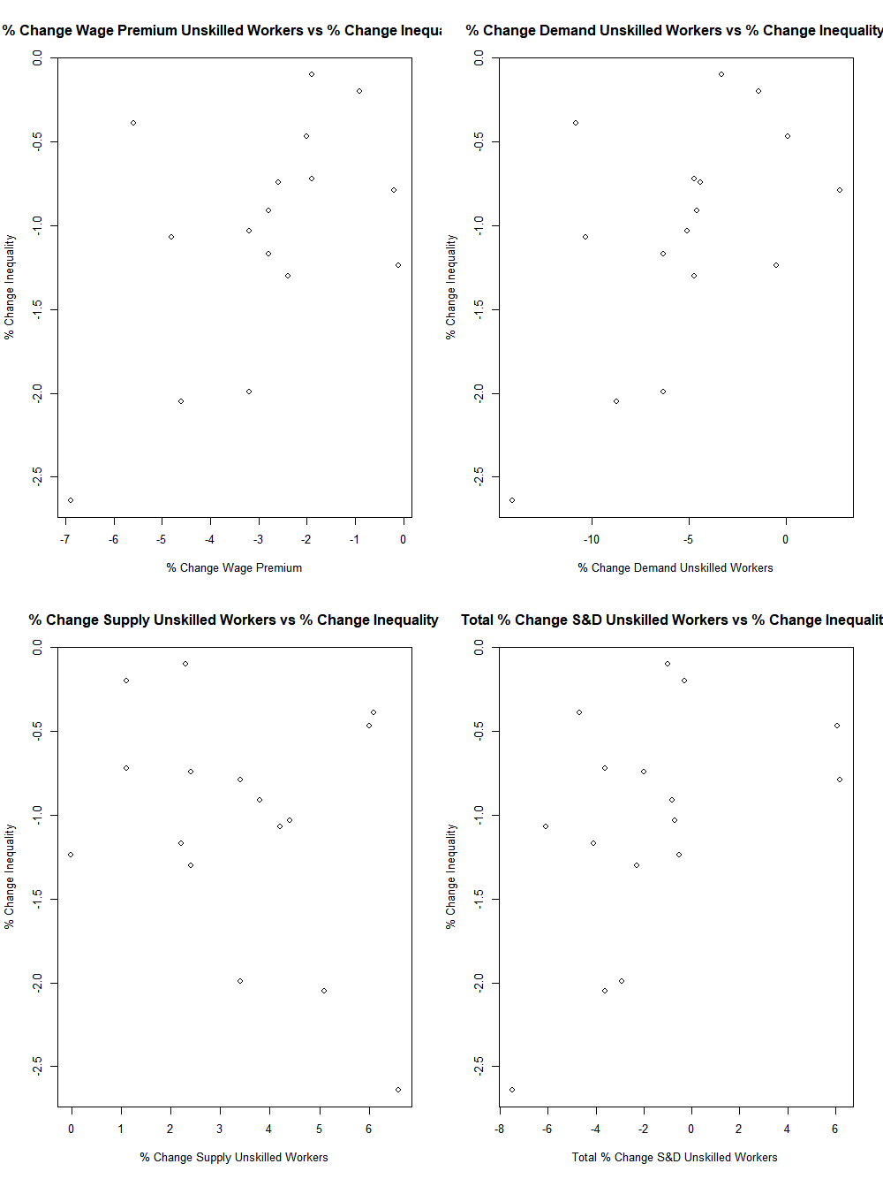

The plots on the previous page indicate the possibility of a slightly positive relationship between each of the variables and the Gini. To test Lustig’s hypothesis, the Gini was regressed on both the supply and demand of unskilled workers, the aggregated for supply and demand for unskilled workers, and the wage premium, all of which are in average annual percent change. As with the previous study on education, only output for the aggregate will be shown; all other results may be recreated using the code posted on GitHub.

> summary(lm(formula = y ~ TotalChangeinsupplyanddemandunskilledworkers))

Call:

lm(formula = y ~ TotalChangeinsupplyanddemandunskilledworkers)

Residuals:

Min 1Q Median 3Q Max

-1.07324 -0.33598 -0.00802 0.40283 0.92589

Coefficients:

Estimate Std. Error t value Pr(>|t|)

(Intercept) -0.89478 0.17516 -5.108 0.000159 ***

TotalChangeinsupplyanddemandunskilledworkers 0.08960 0.04395 2.039 0.060836 .

---

Signif. codes: 0 ‘***’ 0.001 ‘**’ 0.01 ‘*’ 0.05 ‘.’ 0.1 ‘ ’ 1

Residual standard error: 0.6304 on 14 degrees of freedom

Multiple R-squared: 0.2289, Adjusted R-squared: 0.1738

F-statistic: 4.156 on 1 and 14 DF, p-value: 0.06084

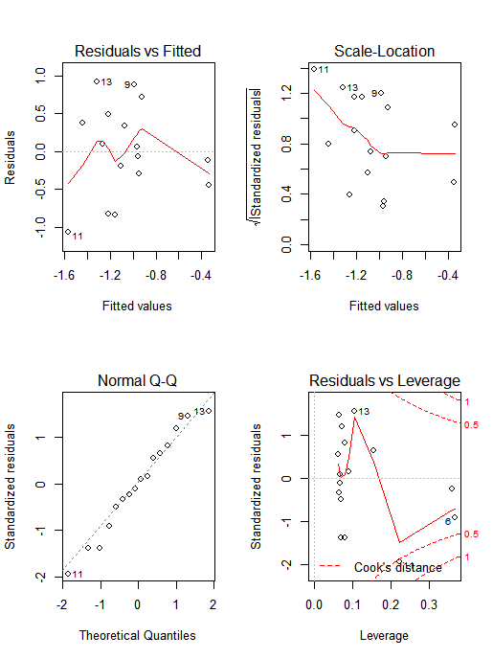

For the previous sequence of regressions, Lustig’s conclusions were confirmed at the 10% level for the aggregate and at the 5% level for the change in demand for unskilled workers and the wage premium. However, her analysis that a percent change in the average annual supply of unskilled workers was not able to be verified.

**Part II Section D: Analysis of Lustig’s Analysis**

Overall, roughly half of the conclusions Nora Lustig wrote about pertaining to education, supply and demand of unskilled labor, and wage premiums in relation to inequality turned out to be reproducible. The following conclusions were confirmed.

1. Inequality has been impacted by changes in returns to tertiary education.
2. Inequality has been impacted by fluctuations in the wage premium for skilled labor, total change (this is the aggregate) in supply and demand for unskilled workers, and total change in demand for unskilled workers.

The following conclusions were not able to be confirmed.

1. Inequality has been impacted by changes in returns to primary or secondary education as well as the aggregate (defined as the average return) in terms of returns to education.
2. Inequality has been impacted by the percent change in the average annual supply of unskilled workers.

The lack of ability to reproduce all of Lustig’s conclusions could have a myriad of causes. However, the lack of reliable reproducibility could be indicative that her research may not have as much validity as originally thought. It is possible that some elements were manipulated in Lustig’s data that are not clearly stated in the papers she has published. It should also be noted that in all of her papers, her analysis is more qualitative than quantitative.

**Part III: Future Research**

Although many possible explanations for the change Latin America’s inequality levels over the past two decades have been discussed, there are many opportunities for future research and expansion. Using R, Python, or other statistical languages/tools, more of Lustig’s work could be reproduced with a more robust dataset and larger timeframe, preferably with every country in Latin American included (rather than just 16). Other options include using alternative regression models that are logarithmic rather than linear, digging deeper into why some of the research in her papers is not reproducible, and even taking a time series approach using panel data for each variable.

Another option would be to look into whether or not the signing of NAFTA (North American Free Trade Agreement) impacted total trade. At this time, an excel file ready for analysis in R with panel data for this has been uploaded to the GitHub repository. It is fairly robust and contains data for a few more countries as well as data for the following variables on a country by country basis over time: total trade, capital imports, capital exports, raw material exports, manufactured good exports, consumer good exports, intermediate good exports, and textile exports. Developing lag based AR(p) or IGARCH models for this dataset may be a subject of interest as well.

Predicting changes and fluctuations in terms of income inequality and inequality will always be a difficult practice for economists and policy makers due to the vast amount of variables that can affect it. Some countries such as Haiti, Nicaragua, and Venezuela have seen persistently high levels for decades; though they have made changes in monetary, fiscal, and socioeconomic policy, little has changed. At the end of the day, each country’s circumstances and potential ways to improve are uniquely its own.

**Part IV: Bibliography**

Acemoglu, D. (2002). “Technical change, inequality, and the labor market”, Journal of Economic Literature 40, 7-72.

Acemoglu, D. (2003). “Patterns of skill premia”, Review of Economic Studies 70, 199-230.

Acosta, P. and Gasparini, L. (2007). “Capital accumulation, trade liberalization, and rising wage inequality: the case of Argentina”, Economic Development and Cultural Change, 55 (4), pp. 793-812, July.

” In Declining Inequality in Latin America: A Decade of Progress?” Luis Felipe López Calva and Nora Lustig, chapter 6. Washington DC: Brookings Institution.

Bourguignon, F., F. Ferreira, and N. Lustig, eds. (2005). The Microeconomics of Income Distribution Dynamics in East Asia and Latin America. Washington, DC: The World Bank/ Oxford University Press.

Card, D. and DiNardo, J. (2006). “The Impact of Technological Change on Low-Wage Workers: A Review.” In Rebecca M. Blank, Sheldon H. Danziger, and Robert F. Schoeni, editors. Working and Poor: How Economic and Policy Changes Are Affecting Low-Wage Workers (New York: Russell Sage Foundation).

Gasparini, L., G. Cruces and L. Tornarolli (2010). “Recent trends in income inequality in Latin America” Economia, forthcoming 2010.

López-Calva, L. and N. Lustig (2010). Declining Inequality in Latin America: A Decade of Progress? Washington, DC: Brookings Institution.

World Bank (2006). World Development Report 2006: Equity and Development. The World Bank, Washington D.C.

Verhoogen, E. (2008). “Trade, Quality Upgrading, and Wage Inequality in the Mexican Manufacturing Sector.” The Quarterly Journal of Economics, MIT Press, vol. 123(2), pages 489-530.